Trisia Baltazar

Due: 10/23/17

CIS 310-02-4178

Assignment 7

Part 1

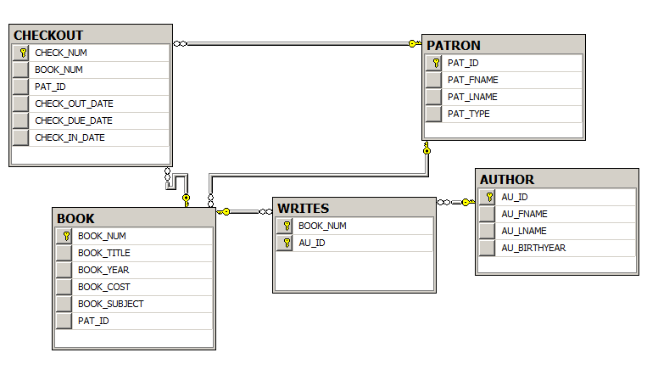

Part 2

--65

SELECT BOOK_TITLE, BOOK_COST, BOOK_YEAR

FROM BOOK

--66

SELECT PAT_FNAME, PAT_LNAME

FROM PATRON

--67

SELECT CHECK_NUM, CHECK_OUT_DATE, CHECK_DUE_DATE

FROM CHECKOUT

--68

SELECT BOOK_NUM, BOOK_TITLE, BOOK_YEAR

FROM BOOK

--69

SELECTDISTINCT BOOK_YEAR

FROM BOOK

--70

SELECTDISTINCT BOOK_SUBJECT

FROM BOOK

--71

SELECT BOOK_NUM, BOOK_TITLE, BOOK_COST

FROM BOOK

--72

SELECT CHECK_NUM, BOOK_NUM, PAT_ID, CHECK_OUT_DATE, CHECK_DUE_DATE

FROM CHECKOUT

ORDERBY CHECK_OUT_DATE DESC

--73

SELECT BOOK_TITLE, BOOK_YEAR, BOOK_SUBJECT

FROM BOOK

ORDERBY BOOK_SUBJECT ASC, BOOK_YEAR DESC, BOOK_TITLE ASC

--74

SELECT BOOK_NUM, BOOK_TITLE, BOOK_YEAR

FROM BOOK

WHERE BOOK_YEAR ='2012'

--75

SELECT BOOK_NUM, BOOK_TITLE, BOOK_YEAR

FROM BOOK

WHERE BOOK_SUBJECT ='DATABASE'

--76

SELECT CHECK_NUM, BOOK_NUM, CHECK_OUT_DATE

FROM CHECKOUT

WHERE CHECK_OUT_DATE <'4/5/2015'

--77

SELECT BOOK_NUM, BOOK_TITLE, BOOK_YEAR

FROM BOOK

WHERE BOOK_YEAR >' 2013'AND BOOK_SUBJECT ='PROGRAMMING'

--78

SELECT BOOK_NUM, BOOK_TITLE, BOOK_YEAR, BOOK_SUBJECT

FROM BOOK

WHERE (BOOK_SUBJECT ='MIDDLEWARE'OR BOOK_SUBJECT ='CLOUD')AND BOOK_COST >'70'

--79

SELECT AU_ID, AU_FNAME, AU_LNAME, AU_BIRTHYEAR

FROM AUTHOR

WHERE AU_BIRTHYEAR >=1980 AND AU_BIRTHYEAR < 1990

--80

SELECT BOOK_NUM,BOOK_TITLE, BOOK_YEAR

FROM BOOK

WHERE BOOK_TITLE LIKE('%DATABASE%')

--81

SELECT PAT_ID, PAT_FNAME, PAT_LNAME

FROM PATRON

WHERE PAT_TYPE ='STUDENT'

--82

SELECT PAT_ID, PAT_FNAME, PAT_LNAME

FROM PATRON

WHERE PAT_LNAME LIKE('C%')

--83

SELECT AU_ID, AU_FNAME, AU_LNAME

FROM AUTHOR

WHERE AU_BIRTHYEAR ISNULL

--84

SELECT AU_ID, AU_FNAME, AU_LNAME

FROM AUTHOR

WHERE AU_BIRTHYEAR ISNOTNULL

--85

SELECT CHECK_NUM, BOOK_NUM, PAT_ID, CHECK_OUT_DATE, CHECK_DUE_DATE

FROM CHECKOUT

WHERE CHECK_IN_DATE ISNULL

ORDERBY BOOK_NUM

--86

SELECT AU_ID, AU_FNAME, AU_LNAME, AU_BIRTHYEAR

FROM AUTHOR

ORDERBY AU_BIRTHYEAR DESC, AU_LNAME ASC

--87

SELECTCOUNT(BOOK_NUM)AS NUMBEROFBOOKS

FROM BOOK

--88

SELECTCOUNT(DISTINCT BOOK_SUBJECT)AS NUMBEROFSUBJECTS

FROM BOOK

--89

SELECTCOUNT(BOOK_NUM)AS AVAILABLEBOOKS

FROM BOOK

WHERE PAT_ID ISNULL

--90

SELECTMAX(BOOK_COST)AS MOSTEXPENSIVE

FROM BOOK

--91

SELECTMIN(BOOK_COST)AS LEASTEXPENSIVE

FROM BOOK

--92

SELECTCOUNT(DISTINCT PAT_ID)AS DIFFERENTPATRONS

FROM CHECKOUT

--93

SELECT BOOK_SUBJECT,COUNT(DISTINCT BOOK_TITLE)AS BOOKSINSUBJECT

FROM BOOK

GROUPBY BOOK_SUBJECT

ORDERBY BOOKSINSUBJECT DESC, BOOK_SUBJECT ASC

--94

SELECT AU_ID,COUNT(DISTINCT BOOK_NUM)AS BOOKSWRITTEN

FROM WRITES

GROUPBY AU_ID

ORDERBY BOOKSWRITTEN DESC, AU_ID ASC

--95

SELECTSUM(BOOK_COST)AS LIBRARYVALUE

FROM BOOK